Carbon Reduction Plan Template
Supplier name: ...…Torton Bodies Limited………………………………………….
Publication date: …15th August 2024…………....................................................

Commitment to achieving Net Zero

Torton Bodies Limited is committed to achieving Net Zero emissions by 2050.

Baseline Emissions Footprint
Baseline emissions are a record of the greenhouse gases that have been produced in the past and were produced prior to the introduction of any strategies to reduce emissions. Baseline emissions are the reference point against which emissions reduction can be measured.

Baseline Year: 2017
Additional Details relating to the Baseline Emissions calculations.
Torton Bodies Limited has not previously assessed or reported its greenhouse gas emissions.

Baseline year emissions:
EMISSIONS | TOTAL (tCO₂e)
Scope 1 | 221.471
Scope 2 | 26.550
Scope 3  (Included Sources) | 30.750 Upstream transportation and distribution  1.057 Waste generated in operations  1.830 Business travel  32.450 Employee commuting  10.455 Downstream transportation and distribution
Total Emissions | 324.563

Emissions Reporting
Reporting Year: 2021
EMISSIONS | TOTAL (tCO₂e)
Scope 1 | 125.908
Scope 2 | 11.530
Scope 3  (Included Sources) | 24.600 Upstream transportation and distribution  0.870 Waste generated in operations  5.300 Business travel  23.002 Employee commuting  5.576 Downstream transportation and distribution
Total Emissions | 196.786

Current Emissions Reporting
Reporting Year: 2022
EMISSIONS | TOTAL (tCO₂e)
Scope 1 | 179.063
Scope 2 | 14.524
Scope 3  (Included Sources) | 18.45 Upstream transportation and distribution  0.870 Waste generated in operations  1.403 Business travel  21.759 Employee commuting  6.355 Downstream transportation and distribution
Total Emissions | 242.424

Current Emissions Reporting
Reporting Year: 2023
EMISSIONS | TOTAL (tCO₂e)
Scope 1 | 217.839
Scope 2 | 13.579
Scope 3  (Included Sources) | 18.911 Upstream transportation and distribution  0.870 Waste generated in operations  1.403 Business travel  18.511 Employee commuting  8.815 Downstream transportation and distribution
Total Emissions | 279.928

Emissions reduction targets

In order to continue our progress to achieving Net Zero, we have adopted the following carbon reduction target.

We project that carbon emissions will decrease over the next five years to 225.00 tCO₂e by 2027. This is a reduction of 7%.

Progress against these targets can be seen in the graph below:

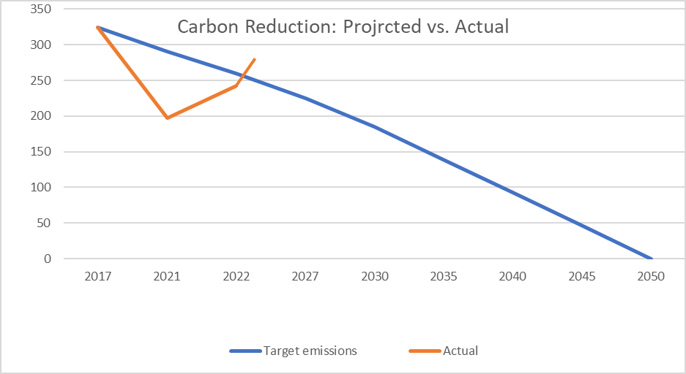

Carbon Reduction Projects

Completed Carbon Reduction Initiatives
2021- The following environmental management measures and projects have been completed or implemented since the 2017 baseline. The carbon emission reduction achieved by these schemes equated to 127.777 tCO₂e, a 39 %ge reduction against the 2017 baseline figures.
2022- These figures have reduced to a saving of 82.14 tCO₂e, a 25.25%ge against the baseline year. The above increase is due to an upturn in the company’s activities (post COVID).
2023- Though scope 2 and 3 emissions have decreased slightly, the total has risen due to increased scope 1 emissions.

The following measures will be in effect when performing the contract.

A solar powered electricity generating system has been installed at our Pilot Works facility.
LED lighting has been fitted throughout both Pilot Works and Hortonwood premises.
Old Kerosene and gas workshop heaters have been replaced with cleaner, more efficient alternatives.
The purchase of a small van. To be used where possible, instead of the company’s 3.5 tonne GVM vans.
The company’s diesel-powered cars are being replaced with electric/plug-in hybrid powered alternatives.

Members of staff have been instructed and encouraged to save energy where possible.
In the future we hope to implement further measures such as:

To replace all the company’s vans, trucks and forklifts with electric/greener powered alternatives.
To expand the company’s solar powered electric generating capacity.
To build our products upon base vehicles powered by the most environmentally friendly formats such as electricity.
To purchase goods from companies using environmentally friendly transport.
To use environmentally friendly hauliers to provide the company’s collection and delivery services.

Declaration and Sign Off
This Carbon Reduction Plan has been completed in accordance with PPN 06/21 and associated guidance and reporting standard for Carbon Reduction Plans.
Emissions have been reported and recorded in accordance with the published reporting standard for Carbon Reduction Plans and the GHG Reporting Protocol corporate standard and uses the appropriate Government emission conversion factors for greenhouse gas company reporting.
Scope 1 and Scope 2 emissions have been reported in accordance with SECR requirements, and the required subset of Scope 3 emissions have been reported in accordance with the published reporting standard for Carbon Reduction Plans and the Corporate Value Chain (Scope 3) Standard.
This Carbon Reduction Plan has been reviewed and signed off by the board of directors (or equivalent management body).

Signed on behalf of the Supplier:

… Andrew Scott …. Compliance Manager….
Date…15th August 2024…….

https://ghgprotocol.org/corporate-standard
https://www.gov.uk/government/collections/government-conversion-factors-for-company-reporting
https://ghgprotocol.org/standards/scope-3-standard

